**Green Society Public School**

**D-25**

**Ratnanagar-7, Sauraha, Chitwan**

**First Terminal Examination-2082**

**Class: U.K.G Time: - 2 hrs. F.M.: 50**

**Sub: Project Work**

|  |
| --- |
| **Name: Roll No.: Sec.:** |
| **­­­­­­­­­­­­ ________________ ______________ OBT.MARKS:**  **INVIGILATOR EXAMINER** |

1. 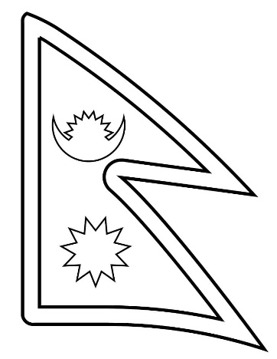**Colour it. [10]**
2. 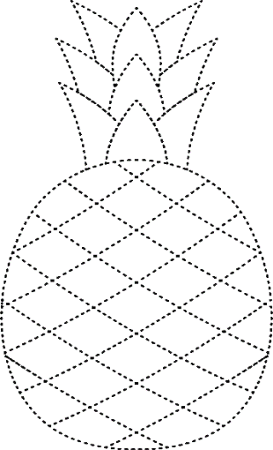**Join the dotted line and colour it. [10]**
3. **Draw a picture of butterfly and color it. [10]**
4. 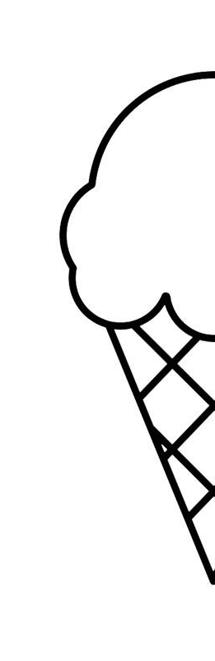**Complete the half picture and color it. [20]**

**The End**